How can enable Two-factor authentication in Pgadmin4

Two-factor authentication is a great feature of Pgadmin-4.11. I will show you how to enable it from the web version which is set up in the ubuntu server.

**Pre-requisite:**

1. Smart Phone of android or iOS
2. Microsoft Authenticator App
3. Pgadmin4 configured in linux/ubuntu server

**How Can install authenticator app in smart phone:**

1. Go play store from your smart phone & search “Microsoft Authenticator”. You will see an window like below picture. Install it as I already installed that’s why it shows Open otherwise it will show install button.

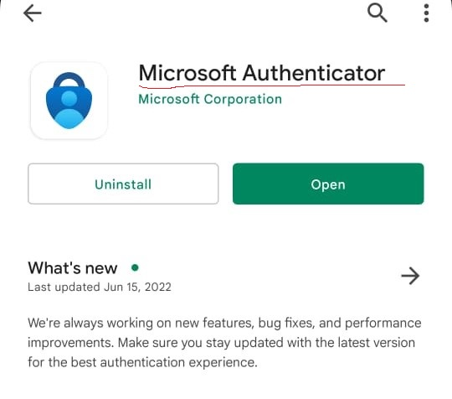

1. After installation you will get it in the app list like below picture.

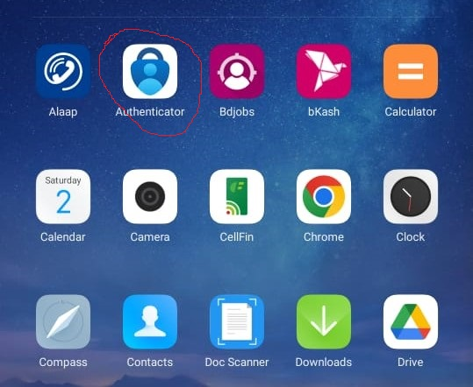

1. Open the app, initially you will do not see any account. I have used it for 4 accounts as authenticator.

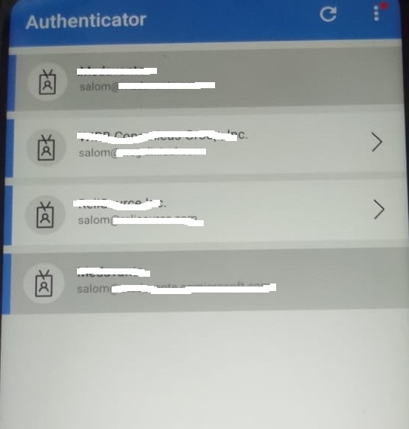

**Enable two-factor authentication in pgadmin4 steps:**